Spring 2024 Update

Hello,

Spring is here and it's a perfect time for me to provide you with a short update about what's been happening in Comox, including some recent "home runs" and "strikeouts".

Home runs:
Doctor recruitment
- 44 new Family Doctors and 8 Nurse Practitioners have moved to the Valley in the past 2 and a half years.
- Over 14,000 people have been connected with a new primary care provider since 2021, with the number growing every week.
- Here's a CBC interview that I did recently with Gregor Craigie about our recruitment efforts.
- You can read more about it in this Times Colonist article.
- A huge thank you to the Division of Family Practice and the members of the Family Physician Recruitment Task Force.
- If you still need a family doctor, you can sign up for one here.
New Strategic Plan for Comox
- I am so proud of the Town of Comox' new Strategic Plan.

- 4 major lenses are now being used by Comox Council to make every decision:
a) Climate
b) Accessibility
c) Fiscal Responsibility
d) Reconciliation

Our Council also highlighted 3 core values by which to conduct our meetings and work:
i) Respectful Dialogue
ii) Embracing Diversity
iii) Disciplined Decision Making

Climate Action Plan
- The Town of Comox is currently undertaking a Climate Change Risk Assessment and developing a Climate Change Action Plan. Stay tuned for more info about this in the coming months.

It has been a pleasure to work with Mayor Minions and my fellow Comox Councillors this term!
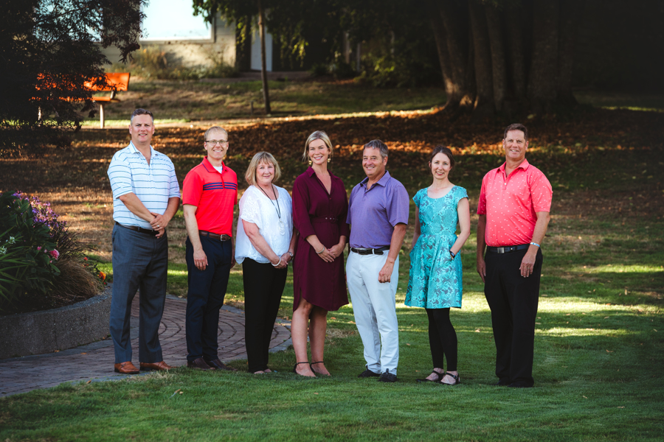
You can view a record of how I voted on important issues at Comox Council and at the Comox Valley Regional District board here. Here are some highlights from the past few months:
- YES vote in support of developing a response to the housing crisis by establishing a housing corporation (or other similar vehicle) that focuses on the creation of non-market rental housing. (CVRD Board)
- YES vote in support of the Comox Valley Conservation Partnership being included as a referral agency in all major rezoning applications. (Comox Council)
- YES vote in support of Comox becoming the first Certified Bat-friendly community on the island, and only the second in BC. (Comox Council)
- YES vote in support of Residential Emissions Reduction Action Plan that prioritizes actions and leverages existing opportunities to further accelerate energy retrofits and residential emission reduction. (CVRD Board)
- YES vote in favour of Comox adopting a new Accessibility Framework, in partnership with the CV Accessibility Committee and the CVRD. (Comox Council)
- YES vote in support of an E-Bike sharing program in Comox. (Comox Council)
- YES vote in support of providing free menstrual products and safer sex supplies in Town owned facilities. (Comox Council)

Strikeouts:

Unfortunately, not every vote went the way that I had hoped. Here are 3 examples:
Traffic speeds
- I proposed a motion aimed at reducing traffic speeds in residential neighbourhoods and in the downtown core, based on the concerns that I have heard from Comox residents. Unfortunately, this motion was defeated by a close 4 to 3 vote. But perhaps this has planted a seed and we can bring this issue back up for discussion.
Bike Pump Track
- I supported Mayor Minions' motion prioritizing the construction of a bike pump track in Comox in response to the 2021 Youth Outdoor Recreation Needs Assessment. Unfortunately, this project was stalled after a 4-to-3 vote by Council on Dec 6th, 2023.
- I remain hopeful that we can get this project completed for our Town's youth sometime in the near future!

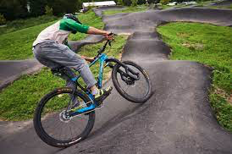

Second Turf Field
- At the Recreation Commission and CVRD Board meetings, I supported the construction of a second turf field, to be used by our local soccer, baseball, and rugby clubs, as our community is growing and the need for more sports fields is clear. This project was suspended for a year, but hopefully we can get it back on track in 2025.

I invite you to watch Comox Council meetings on YouTube on most Wednesday evenings at 5pm, or you can watch the recording anytime that is convenient to you. The agendas are posted each Monday.

Upcoming Opportunities to Have Your Say:

Our community is better when residents from all walks of life are engaged and provide local governments with their feedback and opinions. Here are some upcoming ways that you can have your say:

Parks and Trails Master Plan
- Comox is currently undergoing a review of its Parks and Trails and I encourage you to share your thoughts. Ideas received will help shape the Town’s first Parks and Trails Master Plan, which will guide how the Town improves its parks and trails over the next decade and beyond.
- You are invited to attend an Open House on Thursday, April 11th from 4:00pm to 6:30pm at the d'Esterre Seniors' Centre.
- You can also provide your feedback online at: https://engagecomoxvalley.ca/comoxparks
Official Community Plan
- Later this year, Comox will be undergoing a renewal of its Official Community Plan, which is a very important document used to direct future planning and development in Town. This process is especially important right now as Bill 44 from the Province will be putting tremendous pressure on our community to build more housing as soon as possible.
- How big should Comox grow and how fast? If you want to provide your thoughts on housing, traffic, bike lanes, wildlife protection, or any other topic, stay tuned for ways to get involved, both in-person and online.

Upcoming Events:

Saturday, April 20th, 11am - Wake for the Trees (corner of Pritchard and Cambridge)
- A local community group is hosting an opportunity to mourn the loss of the trees at a future housing development site adjacent to the Northeast Woods.

Monday, April 22nd, 1pm-5pm - Earth Day Event at St. Peter’s Church (218 Church Street)
- The third annual Earth Day Event at St. Peter’s Church in Comox will host a number of local environmental groups showcasing ideas for what the community can do to move towards a more sustainable future, with music, video, presentations, activities, and refreshments.
Personal Updates:

This past fall, it was an honour to be chosen by my fellow elected officials to serve as the Vice-Chair of the Comox Valley Regional District Board, made up of elected representatives from Courtenay, Cumberland, Comox, and rural Areas A, B, & C. It has been so interesting and rewarding to be involved with the regional approach to providing services to Comox Valley residents, such as water, sewer, and recreation.

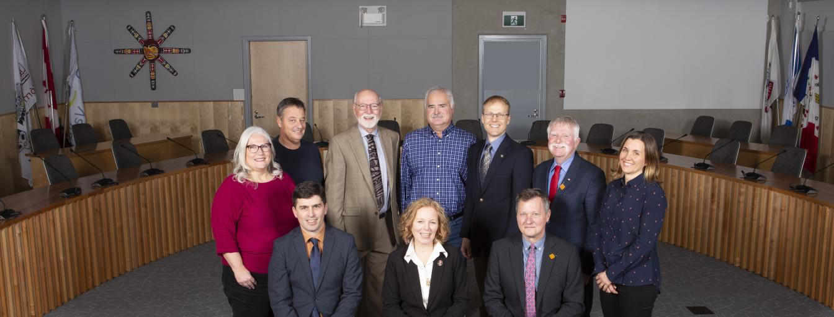

Spring can be a bittersweet time of year for me as the biathlon competition season wraps up. I competed at 6 BC Cup races and had some amazing moments, as well as some challenging ones. That's the nature of sports (and life!).

The highlight of the season for me was the opportunity to coach our Vancouver Island biathlon team at the BC Winter Games in Quesnel. I was so proud of how hard they trained, how they competed, and how they cheered on each other, and other athletes from across the province.
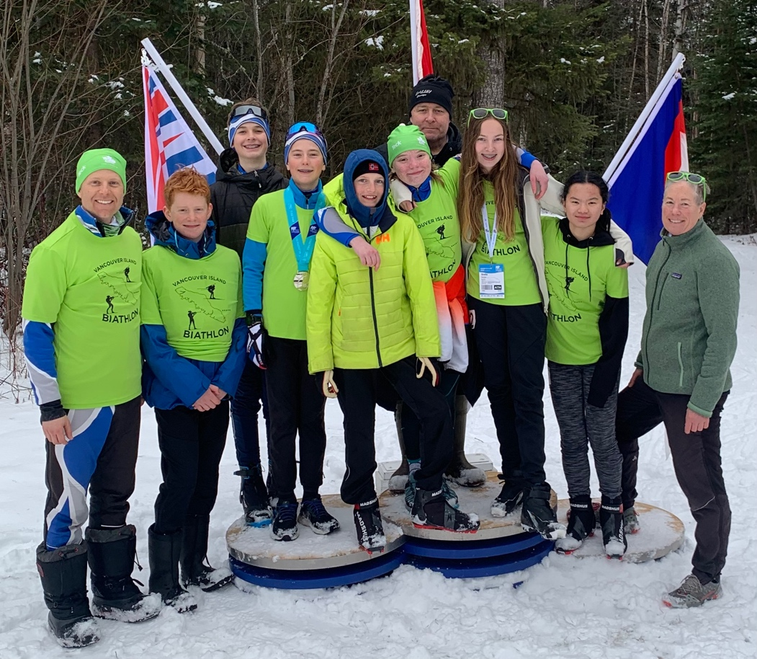

If you have any specific Town of Comox issues that you would like to discuss or want to let me know about, please email me at jkerr@comox.ca

Feel free to connect with me anytime if you have a question, a concern, or if I can be of service in any way.

Looking forward to seeing you around town, on a local trail, or at the Comox Nautical Days Festival this summer.

Have a wonderful day,

Jonathan
--
Jonathan Kerr, MD, CCFP, FCFP
(He/Him)
healthycomox@gmail.com
www.healthycomox.ca
Healthy Community, Healthy People, Healthy Environment
“Real change, enduring change, happens one step at a time.”
– Ruth Bader Ginsburg
I respectfully acknowledge that I live, work, and play on the Unceded Traditional Territory of the K'ómoks First Nation.

