March 7th, 2022
Hello,

It's hard to believe it has already been 100 days since I was sworn in as a Councillor for the Town of Comox. It was wonderful to share the occasion with my partner Christy, and our children Gwenyth and Tobin.

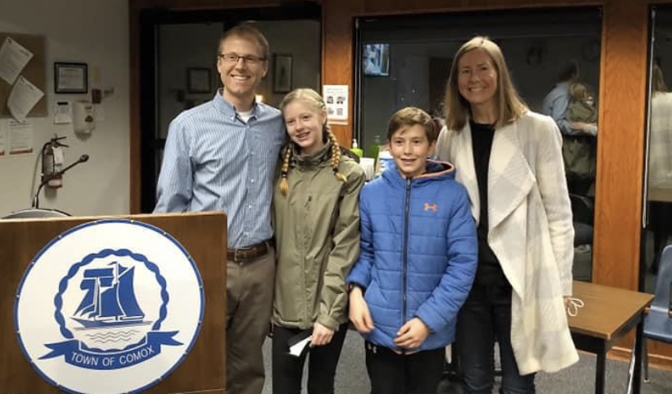

Early Wins

I am excited to share with you some early wins from my first 100 days on Comox Council:

- After the Comox Youth Climate Council presented their "Green New Deal" to Comox Council on Feb 2nd, I made a motion asking the Town's administration to review the proposed policies, provide recommendations to Council, and incorporate the analysis into the reporting of the Town’s green initiatives as part of the upcoming Green Open House in June. (Motion passed). You can listen to my comments during the Feb 2nd Council meeting by going to the 1:00:10 mark of this recording.
- Voted YES to a new Affordable Housing Contribution policy focused on the long-term acquisition of units by the Town. These units acquired over time will be used to provide affordable housing for Comox residents. (Motion passed). You can listen to my comments during the Feb 16th Council meeting by going to the 44:42 mark of this recording.
- Made a motion and voted YES to a new Tree Retention policy. I also proposed amending the motion to increase tree retention from 25% to 30%. (Motion passed) You can listen to my comments during the Feb 16th Council meeting by going to the 1:47:58 mark of this recording.

- Voted YES in favour of the creation of a Heritage Registry policy which will allow for the acknowledgement and protection of significant heritage properties in the Town of Comox. (Motion passed)

- Voted YES to support MP Gord John’s private members bill C-126 aimed at addressing the toxic drug supply in B.C. (Motion passed.)

- Voted YES to support the Comox Valley Regional District to apply for, receive, and manage the stream two Poverty Reduction grant funding behalf of the Comox Valley Community Health Network. (Motion passed)

- Voted NO on a pay increase for Council.

I believe in transparency as an elected member of Council, so I will be continuing to update the Healthy Comox website with my voting record on key issues. I will also include links to the recordings of the Council meetings, so you can listen to my comments and reasoning for each vote.

Thinking Globally
It was an honour to stand united with my fellow Comox Councillors, the Mayor, and Town Staff as the Ukrainian flag was raised at Town Hall last week. My heart goes out to the innocent people of Ukraine and Russia who are suffering needlessly at the hands of a dictator.

The Town of Comox was recently selected in the Partnerships for Municipal Innovation – Women in Local Leadership (PMI-WILL) project. With the majority of the seats on Comox Council being held by women, the Town will have the opportunity to share its experience and best practices with international counterparts to advance gender equalityand inclusive development at the local level. The Town of Comox has been paired with the country of Cambodia and will begin working with their project team and partners in the coming weeks.

Upcoming Issues

Northeast Comox development
- Perhaps the biggest issue that Comox residents and Council will be dealing with over the coming year is the proposed development of 11 privately-owned properties along Pritchard Road (just north of Highland Secondary School). Although these properties are outside of the protected Northeast Woods area, they are currently home to many large trees and wildlife.
- The discussions will likely center around the property owners' rights (to develop their land), figuring out how to protect as many trees and as much wildlife as possible, how much of the development should be allocated for affordable housing, and what the implications of the developments will be on Comox taxpayers. I encourage you to stay informed and participate in any future community engagement meetings.

Family Physician Recruitment
- I am currently serving as the Chair of the Comox Valley Family Physician Recruitment Task Force, which has representation from Comox, Courtenay, Cumberland, the CVRD, the Division of Family Practice, Island Health, the CV Healthcare Foundation, the Chamber of Commerce, and local patient advocates.
- Our goal is to recruit and retain enough primary care providers so that everyone in the Comox Valley has their own personal family physician or nurse practitioner.

How to Stay Engaged
- View Council meetings live (or recorded) on the Town's YouTube channel.
- Read past and upcoming Council meeting agendas here.
- Keep track of my votes on key issues at www.healthycomox.ca
- Send me an email at jkerr@comox.ca if you have questions or comments about any local issues.
- Follow me on Facebook, Twitter, or Instagram.

Upcoming Events
- Sunday, May 29th: Second annual Community Listening Event
- June (date TBD): Green Open House hosted by the Town of Comox focusing on climate change adaptation and mitigation strategies.
- July 30th to August 1st: Nautical Days Weekend
Thank You

Thank you to the over 65 volunteers and countless supporters for your time, energy, and enthusiasm last fall during the campaign. I am honoured and humbled to have the opportunity to represent you and our shared values at the Council table.

A special thank you to my fellow Councillors, Mayor Arnott, CAO Jordan Wall, and the rest of Town staff for making me feel so welcome.

I would also like to thank everyone that has connected with me over the past 100 days, whether it was by email, phone, zoom, or in person. My favourite part of being a Comox Councillor is hearing from engaged residents and having conversations about how we can ensure we have a Healthy Community, Healthy People, and a Healthy Environment.

Sincerely,

Jonathan

--
Jonathan Kerr, MD, CCFP, FCFP
(He/Him)
healthycomox@gmail.com
www.healthycomox.ca
Healthy Community, Healthy People, Healthy Environment
“Real change, enduring change, happens one step at a time.”
– Ruth Bader Ginsburg
I respectfully acknowledge that I live, work, and play on the Unceded Traditional Territory of the K'ómoks First Nation.

