June 26th, 2022
Hello,

Summer is finally here, and today also marks the 200th day since I took the oath of office as a Councillor for the Town of Comox. Here are some updates and upcoming events:

What issues matter most to you in creating a healthy community?

My favourite part of being a Comox Councillor is hearing from residents and having conversations about how we can ensure we have a Healthy Community, Healthy People, and a Healthy Environment.
I invite you to take a minute to share what issues matter to you most by clicking here.

You are invited: Climate Action Open House (June 28th, 3pm-7pm)

I hope you will join me at the upcoming Climate Action Open House to hear about how the Town is currently addressing climate change, and to provide your feedback and ideas.
Tuesday, June 28th, 3pm to 7pm at the Comox Community Centre

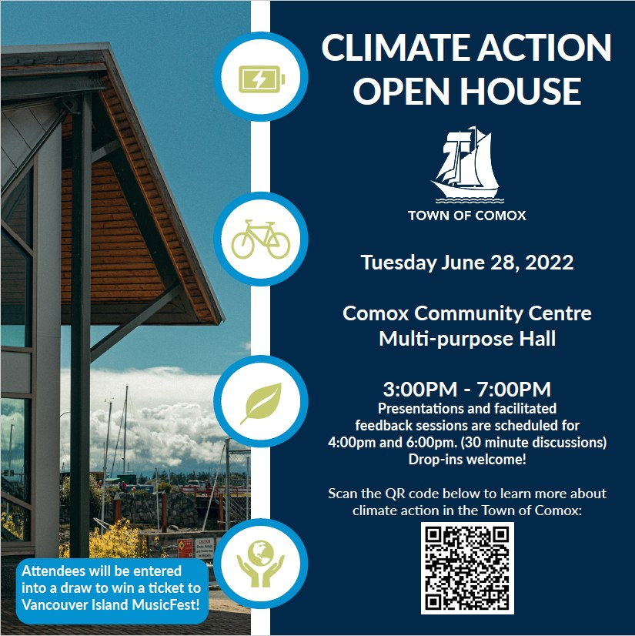

Family Doctor Recruitment:

Good news! We have already recruited 5 new family doctors to the Comox Valley since January, and another 6 family doctors will be coming later this year.
We have attached over 4,100 patients with a new family doctor since July, 2021.

But, there is more work to be done! I am currently serving as the Chair of the Comox Valley Family Physician Recruitment Task Force, which has representation from Comox, Courtenay, Cumberland, the CVRD, the Division of Family Practice, Island Health, the CV Healthcare Foundation, the Chamber of Commerce, and local patient advocates.

Our goal is to recruit and retain enough primary care providers so that everyone in the Comox Valley has their own personal family physician or nurse practitioner.

How did Dr. Kerr vote recently?

I believe in transparency as an elected member of Council, so I will be continuing to update the Healthy Comox website with my voting record on key issues. I will also include links to the recordings of the Council meetings, so you can listen to my comments and reasoning for each vote.

If you have any questions about a particular issue or vote, please send me an email at healthycomox@gmail.com

Community Listening Event recap:

On May 29th, 35 community groups and over 200 attendees took part in the second annual Community Listening Event at the Filberg Heritage Lodge & Park.
In case you missed it, you are welcome to watch a video of the Speakers here.

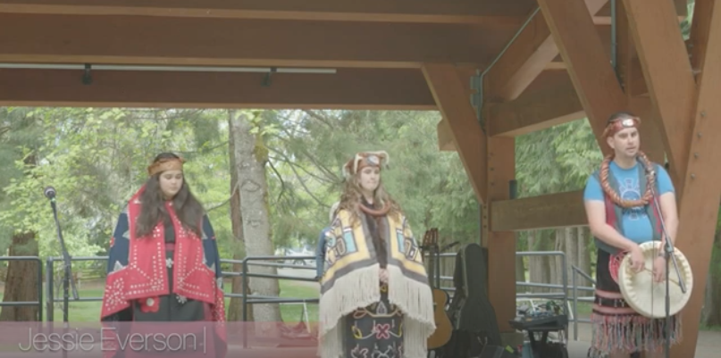
How to Stay Engaged:
- View Council meetings live (or recorded) on the Town's YouTube channel.
- Read past and upcoming Council meeting agendas here.
- Keep track of my votes on key issues at www.healthycomox.ca
- Send me an email at jkerr@comox.ca if you have questions or comments about any local issues.
- Follow me on Facebook, Twitter, or Instagram.
Upcoming Events
- June 28th, 3pm-7pm: Climate Change Open House hosted by the Town of Comox focusing on climate change adaptation and mitigation strategies.
- July 30th to August 1st: Nautical Days Weekend in Comox

Please feel free to get in touch if I can be of any help, or if there are any issues that you'd like to chat about.

I am honoured and humbled to have the opportunity to represent you and our shared values at the Council table.

Sincerely,

Jonathan

--
Jonathan Kerr, MD, CCFP, FCFP
(He/Him)
healthycomox@gmail.com
www.healthycomox.ca
Healthy Community, Healthy People, Healthy Environment
“Real change, enduring change, happens one step at a time.”
– Ruth Bader Ginsburg
I respectfully acknowledge that I live, work, and play on the Unceded Traditional Territory of the K'ómoks First Nation.

